

**DEPT. Of Computer Science Engineering**

**SRM IST, Kattankulathur – 603 203**

**Sub Code & Name: 18CSS201J - ANALOG AND DIGITAL ELECTRONICS**

|  |  |
| --- | --- |
| **Experiment No** | 02 |
| **Title of Experiment** | Design and implement a Schmitt trigger using Op-Amp using a simulation package and demonstrate its working. |
| **Name of the candidate** | Rahul Goel |
| **Register Number** | RA1911030010094 |
| **Date of Experiment** | 13-08-2020 |

**Mark Split Up**

|  |  |  |  |
| --- | --- | --- | --- |
| **S.No** | **Description** | **Maximum Mark** | **Mark Obtained** |
| 1 | Oral Viva / Online Quiz | 5 |  |
| 2 | Execution | 10 |  |
| 3 | Model Calculation / Result Analysis | 5 |  |
| **Total** | | **20** |  |

**Staff Signature with date**

**Aim**

Design and implement a Schmitt trigger using Op-Amp using a simulation package and demonstrate its working.

**Apparatus Required:**

|  |  |  |  |  |
| --- | --- | --- | --- | --- |
| S.No | Particulars | Type | Range | Quantity |
| 1 | Op amp | UA 741 CD |  | 1 |
| 2 | Resistor |  | 10K to 50KΩ | As per required |
| 3 | AC voltage source |  | 10V, 500Hz | 1 |
| 4 | DC voltage source |  | 15 V, 3V | 3 |
| 5 | Voltage Measurement |  |  | 2 |

**Software Required:**

<https://www.multisim.com/>

Theory

Schmitt trigger is essentially a multivibrator having two stable states. The output remains in one of the stable states indefinitely. The transition from one stable state to the other takes place when the input signal changes appropriately (triggers appropriately). Bistable peration needs an amplifier with a regenerative (positive) feedback with loop gain greater than unity. The circuit is often used to convert square waves with slowly varying edges to sharp edges required in digital circuits. It is also used for debouncing the switches.

Schmitt trigger is otherwise called regenerative comparator. In this comparator circuit a positive feedback is added. The input voltage Vi triggers the output Vo very time it exceeds certain voltage levels. These voltages are known as upper threshold voltage (VUT) and lower threshold voltage VLT . The difference between the two threshold voltages (VUT –VLT) gives the hysteresis width.

* The Schmitt trigger is also called regenerative comparator.
* Schmitt trigger is a comparator with hysteresis.
* As it compares the input analog waveform with respect to preset values of VUT and VLT, Schmitt trigger is also known as two level comparator..
* A non-inverting Schmitt trigger circuit is obtained by interchanging Vi and Vref
* When an input sinusoidal signal of frequency f is applied, a square wave of same frequency is produced at the output.
* The square wave amplitude is symmetrical about zero level

**Procedure :**

1. Connections are made as shown in the circuit diagram.

2. A sinusoidal input whose amplitude is greater than the magnitude of the VUT and VLT, is

applied, a square wave output is obtained and tabulated the various value.

3. VUT and VLT, points are noted.

Circuit Diagram:

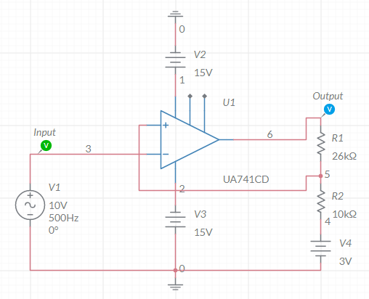

Model graph:

Input and Output waveform

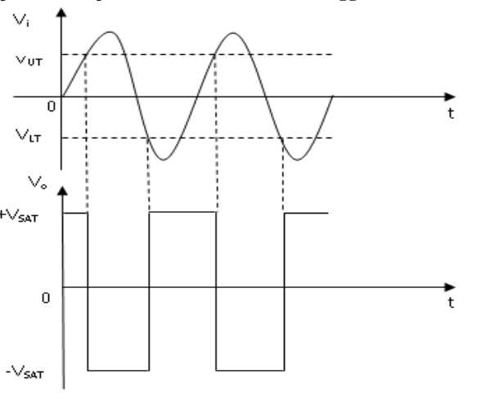

Transfer Characteristics:

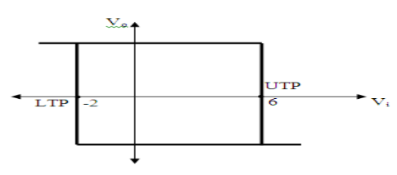

Design Specification

$V_{UT}=\frac{V_{R}R_{1}}{R_{1}+R_{2}}+\frac{V_{sat}R_{2}}{R_{1}+R_{2}}$ (1)

$V_{}=\frac{V_{R}R_{1}}{R_{1}+R_{2}}−\frac{V_{sat}R_{2}}{R_{1}+R_{2}}$ (2)

(1) – (2) $V_{UT}−V_{}=2\frac{V_{sat}R_{2}}{R_{1}+R_{2}}$

(1) + (2) $V_{UT}+V_{}=2\frac{V_{R}R_{1}}{R_{1}+R_{2}}$

Simplify the above equation,

$$V_{R}R_{1}=V_{sat}R_{2}×\frac{V_{UT}+V_{}}{V_{UT}−V_{}}$$

Where,

Vsat = Saturation voltage = 13 V

R2 = 10kΩ

VR = Reference voltage = 3 V

Tabulation

|  |  |  |  |  |  |
| --- | --- | --- | --- | --- | --- |
| **S.No** | **R1 (kΩ)** | **VUT** | | **VLT** | |
| **Theoretical** | **Simulation** | **Theoretical** | **Simulation** |
| 1 | 26 | 4 | 4.07V | -1 | -0.7V |
| 2 | 28.89 | 5 | 5.2V | -1 | -1.1V |
| 3 | 30.95 | 6 | 5.7V | -1 | -1.2V |
| 4 | 21.67 | 6 | 6.3V | -2 | -2.3V |
| 5 | 32.5 | 7 | 6.6V | -1 | -0.89V |

Model Calculation:

For R1=26kΩ

=(3*26)/(26+10)+(13*10)/(26+10)=5.778V

$V_{LT}=\frac{V_{R}R_{1}}{R_{1}+R_{2}}−\frac{V_{sat}R_{2}}{R_{1}+R_{2}}$ =(3*26)/(26+10)-(13*10)/(26+10)=-1.45V

(1) – (2) $V_{UT}−V_{LT}=2\frac{V_{sat}R_{2}}{R_{1}+R_{2}}$ =5.78+1.45=2*13*10/36=7.22V

(1) + (2) $V_{UT}+V_{LT}=2\frac{V_{R}R_{1}}{R_{1}+R_{2}}$ =5.78-1.45=2*3*26/36=4.33V

$V_{R}R_{1}=V_{sat}R_{2}×\frac{V_{UT}+V_{LT}}{V_{UT}−V_{LT}}$ =3*26=13*10*(4.33/7.22)=77.9V

**Simulation Diagram**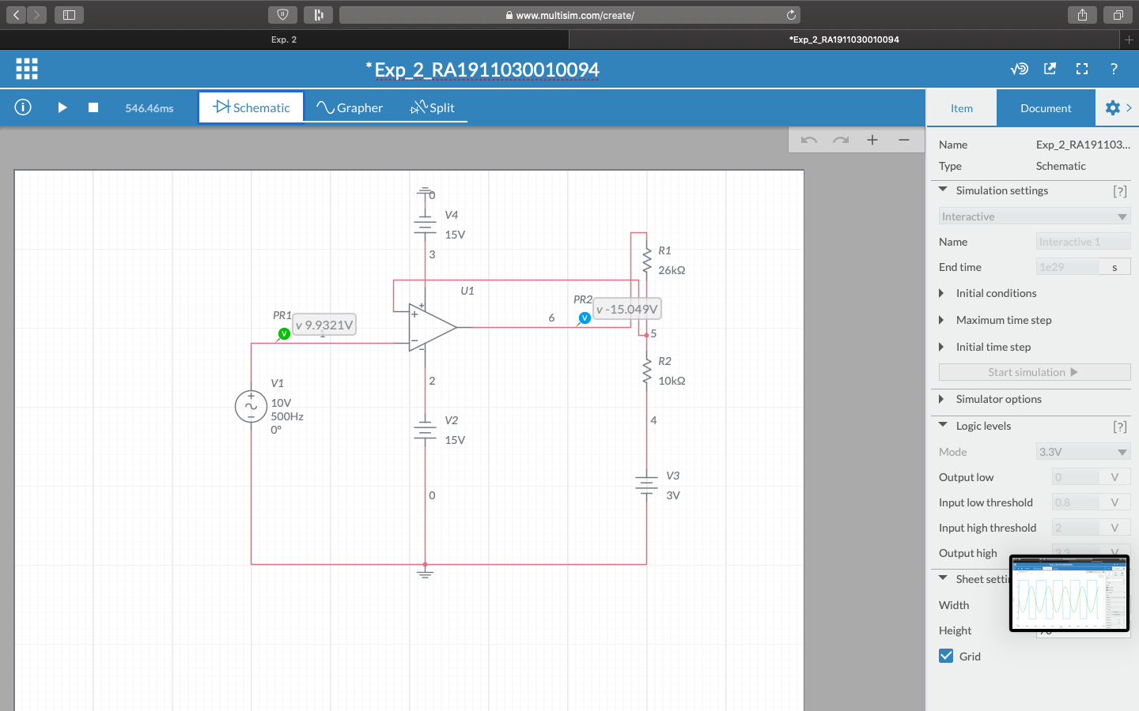

**Simulation waveform:**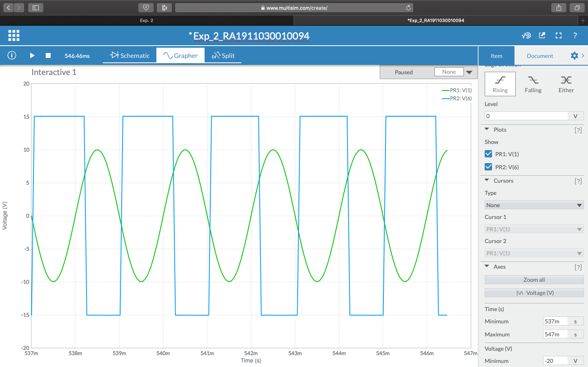

Result:

Thus, the design and performance of the Schmitt trigger were obtained.